**Project 11**

**This is Exercise 35_05**

(*Revise SQLClient.java*) Rewrite Listing 35.1, SQLClient.java, to display the query result in a TableView, as shown in the figure below.

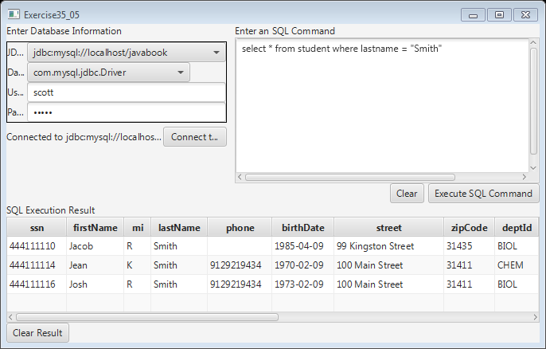

*The query result is displayed in a* TableView*.*

Hint: import javafx.scene.control.TableView;

**Instructions:**

1. Create a folder titled “lib” in the Java project. Add the .jar files from Blackboard into the folder.
2. Right click on the project name in the left sidebar in Eclipse. Go to Build Path > Configure Build Path.
3. Select Add External JARs on the right. When the new window appears select the JAR files in the lib folder. Click OK.
4. Run the program. Select “com.mysql.jdbc.Driver” and “<jdbc.mysql://localhost/javabook>.” The username is scott and the password is tiger. Click Connect to Database.
5. You can now use the text area on the right to enter a SQL query. Click Execute SQL Command. You will now see the results in the SQL Execution Result text area.

**UML:**

**Screenshots:**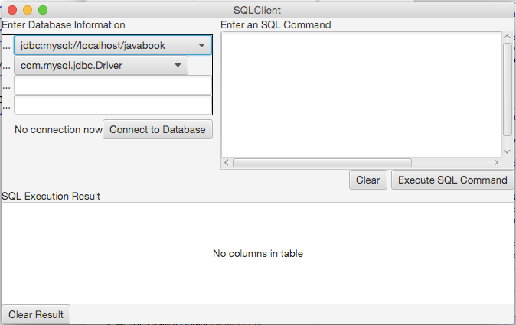

**Continued —->**

